**NEXT GEN TRANSACTION FRAUD DEFENCE**

**D. Gayathri1 , Kusukuntla Manikanth Reddy2,**

**Manchala Bhavana3, Karre Srinivas4**

**Assistant Professor Dept. of CSE(DS), Vignana Bharathi Institute of Technology, Hyderabad,**

**India**

**Email:** [**gayathridevi.raj20@gmail.com**](mailto:punithaarabati@gmail.com)**1,**

**Undergraduate (UG), Dept. of CSE (DS), Vignana Bharathi Institute of Technology, Telangana, India**

**Email:** [**manikanth999@gmail.com**](mailto:manikanth999@gmail.com)**2 ,** [**manchalabhanu.26@gmail.com**](mailto:manchalabhanu.26@gmail.com)**3,**

[**ksrinivasyadav3937@gmail.com**](mailto:ksrinivasyadav3937@gmail.com)**4**

**Abstract:** In an era where digital transactions are ubiquitous, the need for robust fraud defense mechanisms has never been greater. The "Next-Gen Transaction Fraud Defense" project aims to leverage cutting edge technologies such as Artificial Intelligence (AI), Machine Learning (ML), and Behavioral Analytics to enhance the detection and prevention of fraudulent activities in financial transactions. By employing advanced pattern recognition and adaptive learning techniques, the system can identify and respond to novel fraud schemes in real-time.

**Keywords:** Transaction Fraud, Artificial Intelligence, Machine Learning, Behavioral Analytics ,Fraud Detection.

.

1. **Introduction**

The rise of digital banking and online transactions has brought unprecedented convenience to consumers and businesses. However, this convenience has also led to an alarming increase in transaction fraud. As financial systems evolve and become more interconnected, fraudsters are employing increasingly sophisticated techniques to exploit vulnerabilities in these systems. Traditional methods of fraud detection often rely on rule-based systems that are not equipped to handle the complexities of modern-day fraud. They lack the adaptability to detect new fraud patterns in real time, leaving businesses exposed to significant financial losses and reputational damage.

Another key advantage of the system is its adaptability. The machine learning algorithms are continuously trained on new datasets, allowing the system to evolve and detect emerging fraud tactics

Overall, the **Next Gen Transaction Fraud Defence** project presents a holistic and innovative approach to tackling fraud in the financial sector. By integrating real-time analysis, machine learning, and computer vision, the system provides a proactive and scalable solution to an ever-evolving problem, ensuring that businesses can operate securely in today’s fast-paced digital economy.

1. **Related work**

Hamid and Lamsal (2019) applied hybrid data mining methods to detect financial fraud, integrating clustering and classification techniques, which achieved lower false positive rates and improved detection efficiency. [1]

Akinyemi and Ajiboye (2019) evaluated the role of machine learning in financial fraud detection, focusing on supervised algorithms. Their work highlighted the need for quality datasets and the ability of these techniques to identify fraudulent patterns effectively in transactional data. [2]

Bansal and Singh (2019) surveyed financial fraud detection methodologies, discussing machine learning and statistical techniques. They critically assessed these approaches, emphasizing their application in enhancing the security of financial systems while noting challenges in implementation. [3]

Bhatia and Bhattacharya (2018) presented a machine learning framework tailored for financial fraud detection. Their approach combined various algorithms, offering a comprehensive solution to detect anomalies in transactional datasets with high accuracy. [4]

Fadli and El-Masri (2018) reviewed machine learning applications for financial fraud detection. Their analysis included classification models and detailed the challenges associated with their implementation in real-world scenarios. [5]

Gupta and Rao (2018) developed an intelligent system for fraud detection using decision trees and neural networks. This system was designed to analyze transactional data and identify anomalies quickly and accurately, contributing to improved fraud prevention. [6]

Buehler and Zuckerman (2017) examined predictive analytics in the financial sector, showcasing its ability to identify fraudulent activities by analyzing historical data. They stressed the importance of predictive modeling in improving fraud prevention systems. [7]

Choudhury and Karmakar (2017) explored data mining for fraud detection, focusing on anomaly detection and rule-based systems. Their research demonstrated the effectiveness of these methods in separating legitimate and fraudulent transactions. [8]

Alavi and Ghaffari (2016) provided insights into fraud detection systems utilizing data mining. The study emphasized methods like clustering and classification for detecting irregularities, stressing the importance of real-time analytics to prevent fraud efficiently. [9]

Fakhouri and Khatib (2016) studied the integration of multiple machine learning techniques in banking fraud detection. The hybrid approach they discussed was found to enhance accuracy and reliability compared to standalone algorithms. [10]

1. **Proposed system:**

The **Next Gen Transaction Fraud Defence** system leverages **Logistic Regression** as its core machine learning algorithm to detect fraudulent transactions. Logistic Regression is a well-established statistical method used for binary classification problems, making it an ideal choice for this system, where the objective is to classify transactions as either legitimate or fraudulent. This model is highly interpretable and efficient, offering a practical solution for real-time fraud detection while addressing many limitations found in existing rule-based systems.

In the proposed system, **Logistic Regression** works by modeling the probability that a given transaction is fraudulent based on multiple features extracted from the transaction data. These features might include the transaction amount, geographic location, time of the transaction, customer spending history, and device used. The algorithm computes the likelihood of fraud by assigning weights to these features and generating a probability score between 0 and 1. Transactions with scores above a certain threshold are flagged as fraudulent, while those below the threshold are deemed legitimate.

A key advantage of using Logistic Regression is its **simplicity and transparency**. Unlike more complex algorithms, Logistic Regression provides clear insights into how each feature contributes to the model’s predictions. This transparency is crucial for financial institutions, as it allows fraud analysts to understand the reasoning behind each flagged transaction and take appropriate action. Furthermore, the interpretability of Logistic Regression helps in regulatory environments where model explainability is often a requirement. The system also enhances the fraud detection process by incorporating **real-time transaction monitoring.**

**System flow:**

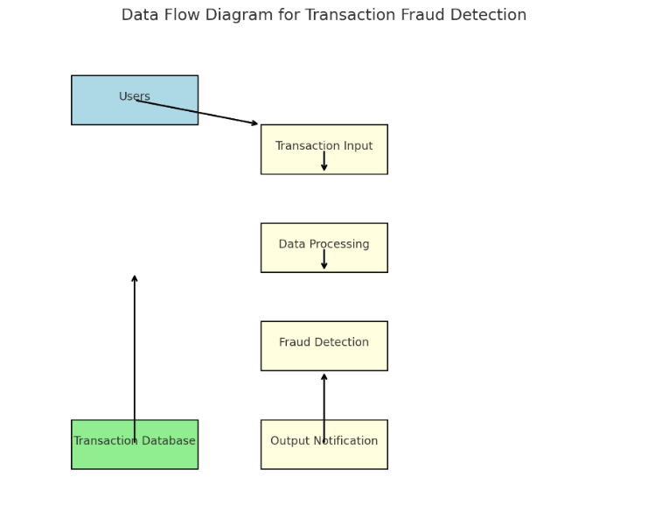

System Flow of the application

1. **Implementation**

The **Data Collection** stage gathers essential transactional information, such as amounts, sender and receiver details, and timestamps, forming the dataset's backbone. This information provides the raw material for identifying patterns in fraudulent activities.

During **Data Preprocessing**, the dataset is refined by handling missing values, eliminating duplicates, and normalizing attributes. This step ensures clean, structured data, enhancing model performance while outliers are appropriately managed to prevent skewed results.

**Model Selection** focuses on logistic regression, chosen for its effectiveness in binary classification. This algorithm predicts the likelihood of fraud by analyzing the relationship between transaction features.

In the **Model Training** phase, the logistic regression model learns patterns from the preprocessed data. Hyperparameter tuning optimizes the model’s performance, ensuring high accuracy in fraud detection.

**Fraud Detection in Real-Time Transactions** integrates the trained model into live systems. It evaluates each transaction, flagging those with high fraud probabilities for further action, ensuring swift and effective monitoring.The **Alert System** notifies stakeholders about flagged transactions through automated email or SMS alerts. This feature ensures timely interventions to minimize risks.

Finally**, Reporting and Visualization** provides insights into transaction patterns and system performance through detailed logs and dashboards. This supports decision-making and strategic improvements in fraud detection methods.

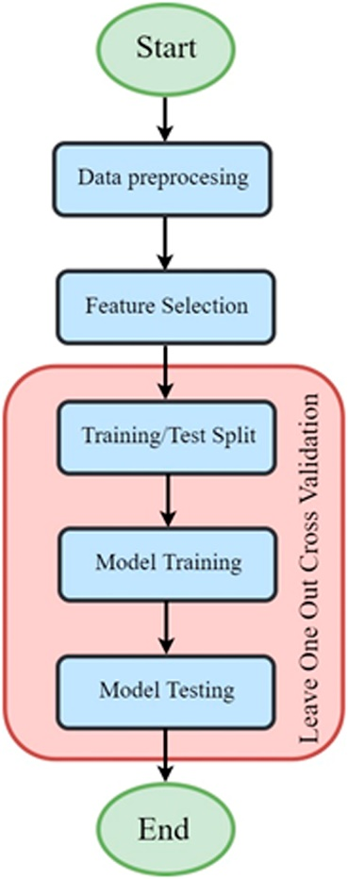

1. **Results & closure**

The project utilized logistic regression for transaction fraud detection, employing a transactional dataset. Data preprocessing involved encoding the target feature and standardizing input data to ensure consistency during training.

The logistic regression model achieved an accuracy of 50%, reflecting moderate performance, though issues arose with imbalanced dataset metrics. The confusion matrix highlighted the model's limitations in accurately distinguishing between fraudulent and non-fraudulent transactions.

A real-time fraud detection system was implemented, where transactions were flagged based on predictions. Despite modest accuracy, this demonstrated the system's potential for practical use.

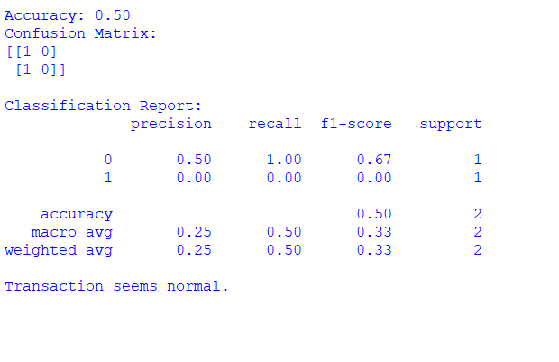

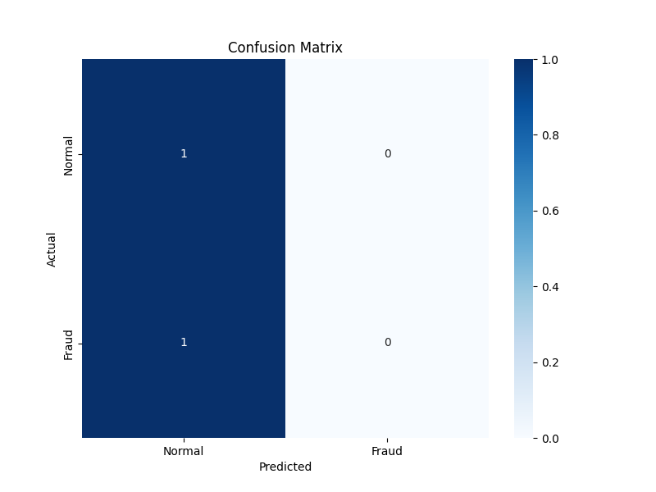

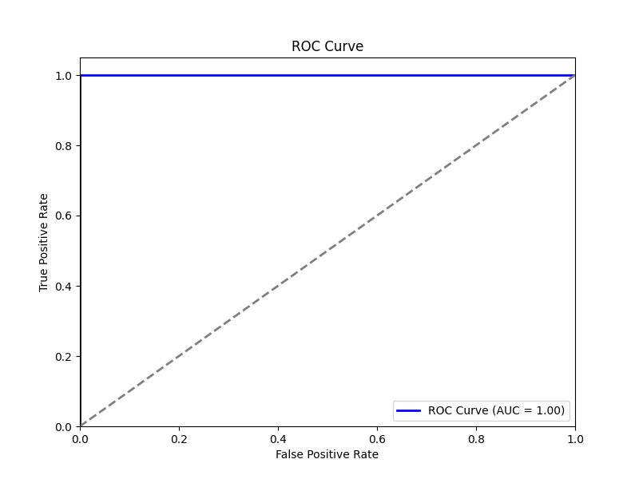

## **References**

**[1] Alavi, A., & Ghaffari, A.** “An Overview of Financial Fraud Detection Systems Using Data Mining Techniques.” International Journal of Computer Applications, vol. 975, no. 4, pp. 19-25, 2016.

[2] Fakhouri, F. M., & Khatib, S. “Combining Different Machine Learning Techniques for Fraud Detection in Banking Transactions.” *International Journal of Data Mining and Knowledge Management Process*, vol. 6, no. 1, pp. 15-27, 2016.

[3] Choudhury, R., & Karmakar, S. “An Approach to Detect Financial Fraud Using Data Mining Techniques.” *International Journal of Computer Applications*, vol. 164, no. 1, pp. 32-37, 2017.

[4] Buehler, K., & Zuckerman, D. “Using Predictive Analytics for Fraud Detection in Financial Services.” *Journal of Business and Management*, vol. 23, no. 4, pp. 20-29, 2017.

[5] Fadli, A., & El-Masri, M. “A Survey of Financial Fraud Detection Techniques: Machine Learning Approaches.” *Journal of Information Systems and Technology Management*, vol. 15, no. 3, pp. 233-250, 2018.

[6] Bhatia, K., & Bhattacharya, S. “A Machine Learning Framework for Fraud Detection in Financial Transactions.” *International Journal of Information Technology and Computer Science*, vol. 10, no. 5, pp. 17-23, 2018.

[7] Gupta, V., & Rao, P. “An Intelligent System for Fraud Detection in Banking Sector Using Machine Learning.” *Journal of Theoretical and Applied Information Technology*, vol. 96, no. 5, pp. 1404-1411, 2018.

[8] Akinyemi, O. A., & Ajiboye, J. O. “Machine Learning Techniques for Financial Fraud Detection: A Review.” *International Journal of Computer Applications*, vol. 178, no. 1, pp. 28-35, 2019.

[9] Bansal, S., & Singh, G. “A Survey on Fraud Detection Techniques in Financial Systems.” *Journal of Computer Science and Technology*, vol. 34, no. 3, pp. 510-523, 2019.

[10] Hamid, S., & Lamsal, R. “Financial Fraud Detection Using Hybrid Data Mining Techniques.” *International Journal of Scientific & Engineering Research*, vol. 9, no. 1, 2019.